1. **Agenda**:
   1. What is WireMock?
   2. Use Cases?
   3. Demo Project Setup?
2. Let’s see the common test scenario **where the WireMock is going to fit in**.
   1. Here 3rd Party API is what we will integrate into out app and we want to test this API and for which we’re writing Junit Test cases or End-To-End Test Cases.
   2. Diagram

      Description automatically generated
3. 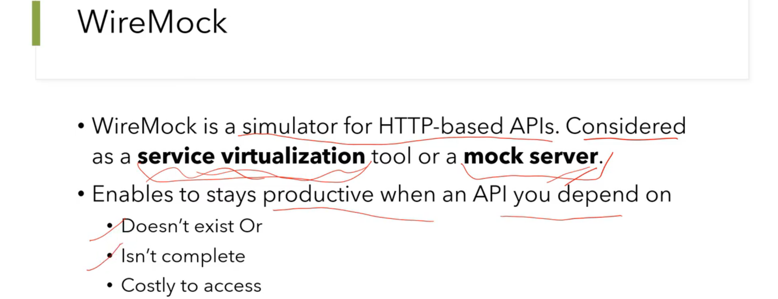
4. Graphical user interface, text, application, email

   Description automatically generated
5. **Features**:  
     
   Text

   Description automatically generated Graphical user interface, text, application

   Description automatically generated
   1. **Stubbing :**
      1. For what response, we want WireMock to return what response.
   2. **Verification**:
      1. We can verify whether a request was made to WireMock with a particular response from the WireMock or not.
   3. **Record-playback of interactions**:
   4. **Injection of faults and delays**:
   5. **Simulation of Stateful behavior**:
      1. HTTP is stateless but we can make stateful using Session, Cookies.
6. 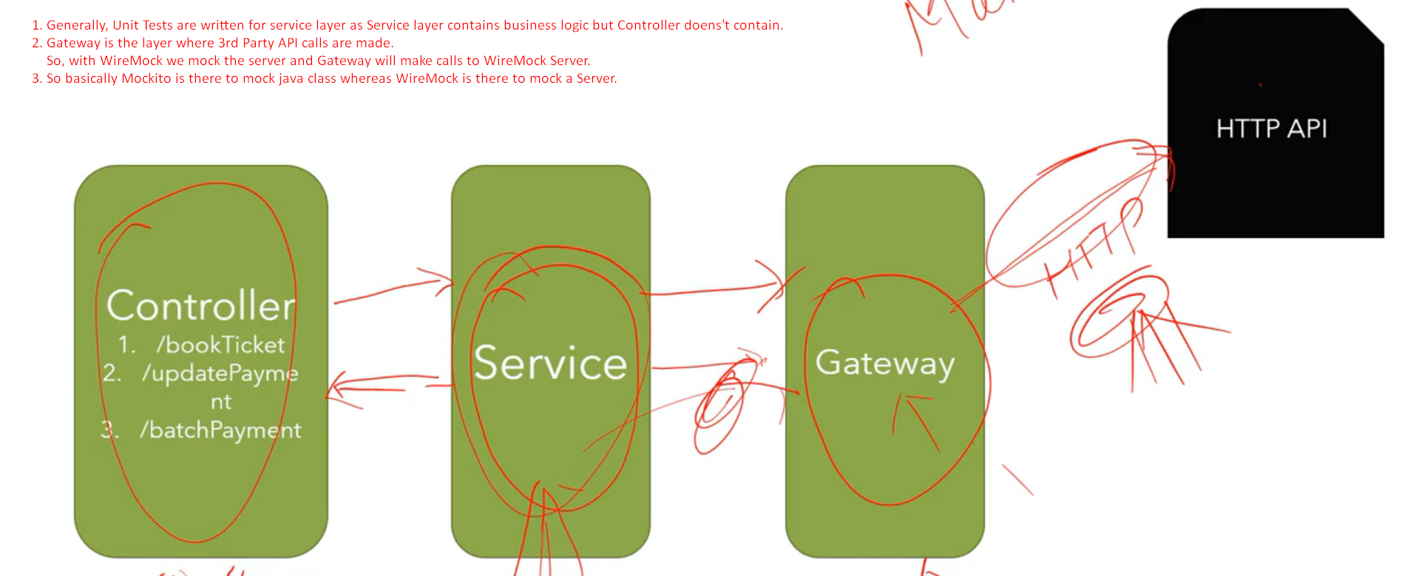
   1. **Gateway**: Your code where 3rd Party API calls are made..
7. Diagram

   Description automatically generated with medium confidence